ROYAL OAK INTERNATIONAL SCHOOL
Sr. Sec. C.B.S.E Affiliated
SESSION: 2019-20
Whole year syllabus of class VI

SUBJECT -ENGLISH

Month | Days |  |  | Content |  | Activities | Worksheet
April | 20 |  |  | New Images:  Ch-1 Mr. Toad’s Adventure  Ch-2 In Morning Dew  Writing : Notice (Announcement)  Grammar : Determiners(Articles and Quantifiers), Sentences  Novel-Ch 1,2 |  | Reading: Ch-1 | Determiners, Sentences  jumbled sentences
May | 8 |  |  | Ch-3 Cat’s Paradise  Writing : Message  Grammar : Noun, Pronoun |  | JAM | Verb, Pronoun
July | 24 |  |  | Ch-4. The Walrus and the Carpenter  Ch5. The lost child  Ch.6. To the cuckoo  Novel-: Ch. 3,4, 5  Writing: Informal Letter, Diary entry Grammar: Verb, Present and Past tense |  | Make tense charts of Present( tenseRoll No. 1-15) and past tense (Roll no. 15 onwards) | Present and Past tense
WRITTEN EVALUATION SYLLABUS: P. A –I M.M. 40
Literature : Ch: - 1,2,3,5 Writing : Notice, Informal Letter
Grammar : Determiners , Sentences , Pronoun
Aug. |  |  | 25 | Ch-7 . The Ransome of Red Chief  Ch-8. The Pobble Who Has No Toes  Novel: Ch 6,7  Writing : Dialogue completion, Formal Letter  Grammar: Adverb, , Adjective, Future Tense | Speaking skill:  Depict a real life incident of any differently able person who inspired you very much. |  | Adverb, Future Tense
Sept. |  |  | 4 | Writing- Bio-Sketch  Grammar: Question Tag | Write a bio-sketch about any famous personality.
WRITTEN EVALUATION SYLLABUS: Half Yearly Exam. - M.M. 80
Complete Syllabus from April to till date
Oct. |  |  | 19 | Ch.9 .(The Special Prize  Ch.10 there will come soft rains  Writing: Article Writing, Data Interpretation  Grammar: Preposition, Voice (Present and Past simple)  Novel-Ch 8,9 | Make 5 Flash cards of ‘Synonyms and Antonyms’ |  | Unseen passage  Preposition, Voice (Present and Past simple)
Nov. |  |  | 14 | Ch-11. There have come soft rains  Ch- 12. The quirks of the Quill  Writing: Story writing, Message  Grammar: Conjunction; Interjection  Novel: Ch 10,11 | Spin a moral based story using various exclamatory words. |  | Conjunction; Interjection
WRITTEN EVALUATION SYLLABUS: P.A.- II M.M. 40
Ch – 9,10,12 Writing : : Article, Story writing, Message
Grammar : Preposition, Voice, Conjunction
Dec. |  | 19 |  | Ch. 13. Fifth from Justice  Ch.14. Mirror  Writing: Advertisement, Paragraph Writing  Grammar: Narration (Assertive sentences)  Novel: Ch 12,13 | Be a marketing executive and promote a product |  | Narration (Assertive sentences)
Jan. |  | 18 |  | Ch. 15 The Hound of the Baskervilles  Writing: Email Writing  Grammar: Subject-Verb Agreement, Editing (error correction)  Novel: Summarization of the novel | Cherish any remarkable incident of your past. |  | Subject-Verb Agreement, Editing
Feb. |  | 10 |  | Revision of whole syllabus for yearly examination
WRITTEN EVALUATION SYLLABUS: Yearly Exam. M M - 80
Complete syllabus from April to Jan.

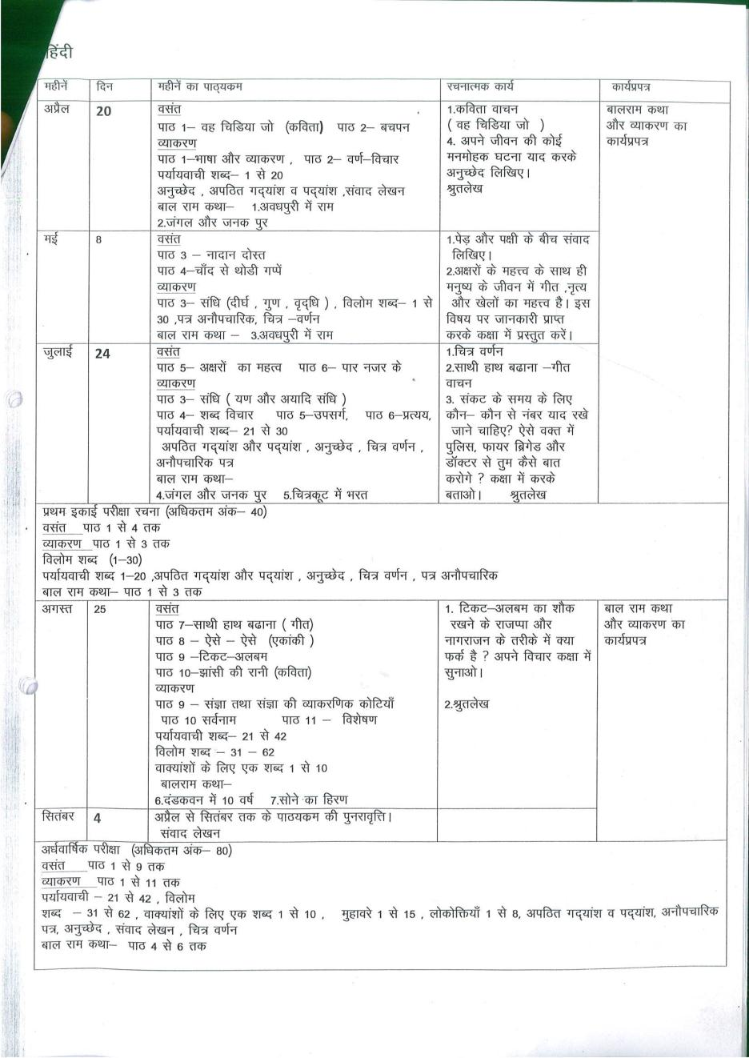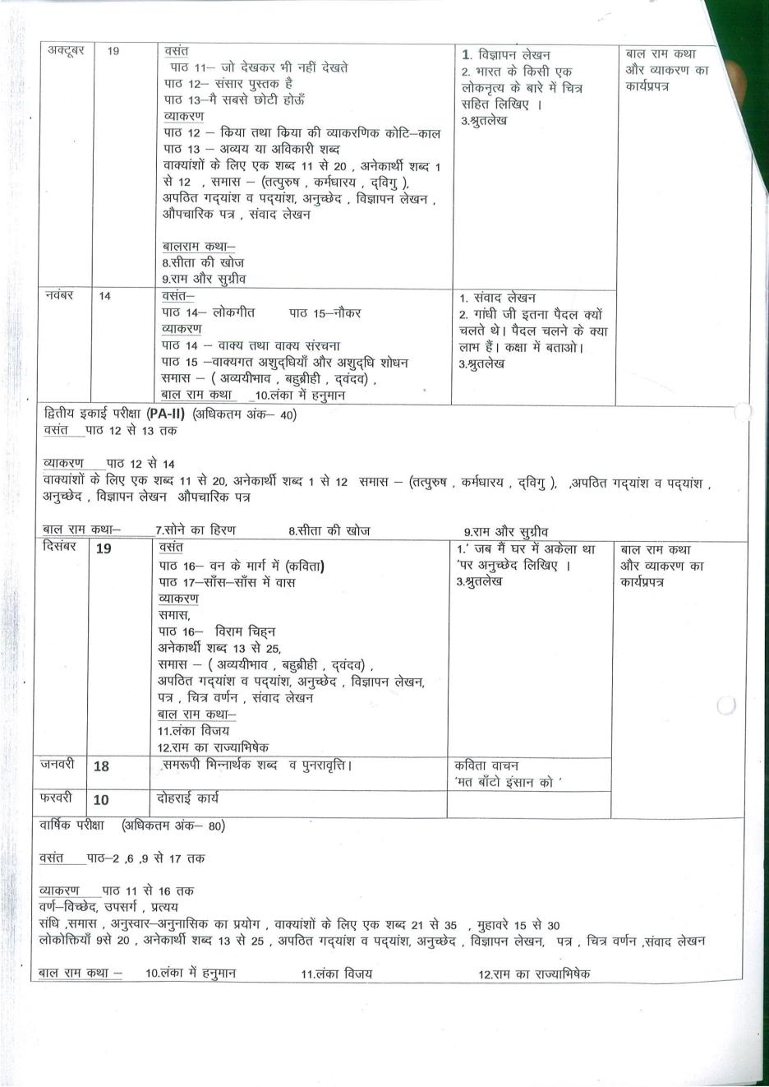
Maths
Month | No. of Days | Topic |  | Concept | Activity |  | Work sheet
April | 20 | Ch 1- Knowing Our Numbers  Ch 2 -Whole Numbers |  | - Place value and Face Value of Numbers | Activity 1: To verify the addition of whole number is commutative  Activity 2 : To verify the Multiplication of whole number is commutative |  | Solve Drill exercise for chapter 1 and 2 from APC Booklets
May | 8 | Ch 3- Playing With Numbers |  | - Operation on Whole Numbers | Activity 3 : To verify the distributive property of multiplication over addition of whole number . |  | Solve Drill exercise for chapter 3 from APC Booklets
July | 25 | Ch 3- Playing With Numbers  Ch 4- Basic Geometrical Ideas |  | - Multiples and  Factors  - Introduction to Geometry | Activity 4 :To find HCF of two numbers |  | Solve Drill exercise from APC Booklets
WRITTEN EVALUATION SYLLABUS: P.A. I M.M. 40
Ch 1, 2, 3, 4
Aug. | 21 | Ch 5 – Understanding Elementary Shapes  Ch 6 –Integers  Ch 7 – Fractions | - Measure of angles  - Positive and Negative numbers |  |  | Activity 5 :To add integers  Activity 6 :To Subtract integers | Solve Drill exercise from APC Booklets
sep | 21 | Ch 7 Fractions | - Fraction on Number Line |  |  | Activity 7: To find fraction equivalent to a given fraction | Solve Drill exercise from APC Booklets
WRITTEN EVALUATION SYLLABUS: Half Yearly Exam M.M. 80
Ch 1,2,3,4,5,6,7
Oct | 19 | Ch 8 Decimals  Ch 10 Mensuration | - Operation on decimals  - Concept of Perimeter and Area |  | Activity 8 : Addition of Decimals |  | Solve Drill exercise from APC Booklets
Nov | 21 | Ch 9 Data Handling  Ch 13 Symmetry | - Organisation of Data  - Lines of Symmetry of different figures |  | Activity 9 :To collect data and represent this through a bar graph |  | Solve Drill exercise from APC Booklets
WRITTEN EVALUATION SYLLABUS: P.A. II M.M. 40
Ch 8,9,10,13
Dec | 20 | Ch 11 Algebra  Ch 12 Ratio and Proportion | - Introduction of variables  - Concept of Ratio |  |  |  | Solve Drill exercise from APC Booklets
Jan | 20 | Ch 14 Practical Geometry  Revision | - Angles using compass |  | Activity 10:To obtain angle bisector of an angle by paper folding |  | Solve Drill exercise from APC Booklets
Feb. | 21 | Revision
WRITTEN EVALUATION SYLLABUS: Yearly Exam M.M. 80
Ch 6,7,8,9,10,11,12,13,14

Science
Month | Days | Chapters To be covered | Activity/  Practicals | Chapters in the  form of Assignment
April | 25 | Ch – 1 Food: Where does it come from?  Ch – 2 Components of food
May | 8 | Ch – 3 Fibre to fabric |  | Ch 4. Sorting Materials Into Groups
July | 25 | Ch – 5 Separation of substances  Ch – 6 Changes around us
WRITTEN EVALUATION SYLLABUS: PA I M.M 40
Ch – 1 , 2, 3, 5
Aug. | 21 | Ch – 7 Getting to know plants  Ch – 8 Body movements
Sep. | 21 | Revision
WRITTEN EVALUATION SYLLABUS: Half Yearly (80)
Ch – 1 , 2, 3, 5, 6, 7, 8
Oct. | 19 | Ch – 9 The living organisms and their surroundings  Ch – 10 Motion and measurement of distances  Ch - 12 Electricity and circuits
Nov. | 21 | Ch - 12 Electricity and circuits (continued)  Ch -11 Light, Shadows and Reflections
WRITTEN EVALUATION SYLLABUS: PA II M.M 40
Ch – 9, 10, 11, 12
Dec. | 20 | Ch – 13 Fun with magnets
Jan. | 20 | Ch – 14 Water Ch – 15 Air around us
Feb. | 11 | Revision
WRITTEN EVALUATION SYLLABUS: Yearly Exam M. M (80)
Ch-2,9,10,11,12, 13,14&15

S.St.
Month |  | Days | Chapters To be covered | Activity | Worksheet  Chapter wise
April |  | 25 | Geo. L-1 The earth in the solar system  His. L-2 On the trail of the earliest people  Geo. L-2 Globe, Latitudes and longitudes | His. L-1 What where ,  how and when  L-6 Kingdoms ,kings  and early republic  L-10 Traders, Kings  and pilgrims  L-12 Buildings, paintings  and books  Geo. L-4 maps  L-7 Our country India  Pol. L-1 Understanding  Diversity  L-2 Diversity and  Discrimination  Diagrams ,  Crosswords ,  Flow Charts,  Map work,  posters ,  Brochures ,  Debate &  Group  Discussion  ( as per the requirement of the  chapter ) | Assignments  &  worksheets  (as per  Requirement  of the chapter  will be  provided)
May |  | 8 | His. L-3 From gathering to growing food
July  (Exams) |  | 25 | Geo. L- 3 Motions of the earth  Pol. L-3 what is government
WRITTEN EVALUATION SYLLABUS: PA I M.M. (40) 4 chapters
H – 2 G- 1,2 P- 3
Aug. | 21 |  | His. L-4 The earliest cities  Geo. L-5 Major Domains of the earth  Pol. L-4 Key elements of a democratic government
Sep | 21 |  | Pol. L-5 Panchayati Raj
WRITTEN EVALUATION SYLLABUS: Half Yearly M. M. (80)
8 chapters
H –2,3, 4 G–2,3,5 P- 4,5
Oct. | 19 |  | His. L-7 New questions and ideas Pol.  L -6 Rural Administration
Nov. | 21 |  | Geo. L-6 Major landforms of the earth
WRITTEN EVALUATION SYLLABUS: PA II M.M.(40)
4 chapters
H-8 G- 6,7 P- 6
Dec. | 20 |  | His. L-11 New empire and kingdoms  L-8 Ashoka , The emperor who gave up war
Jan. | 20 |  | Geo. L-8 India- climate vegetation and wildlife
Feb. | 11 |  | Revision
WRITTEN EVALUATION SYLLABUS: Yearly Exam. M.M. (80)
Whole syllabus (April – January)

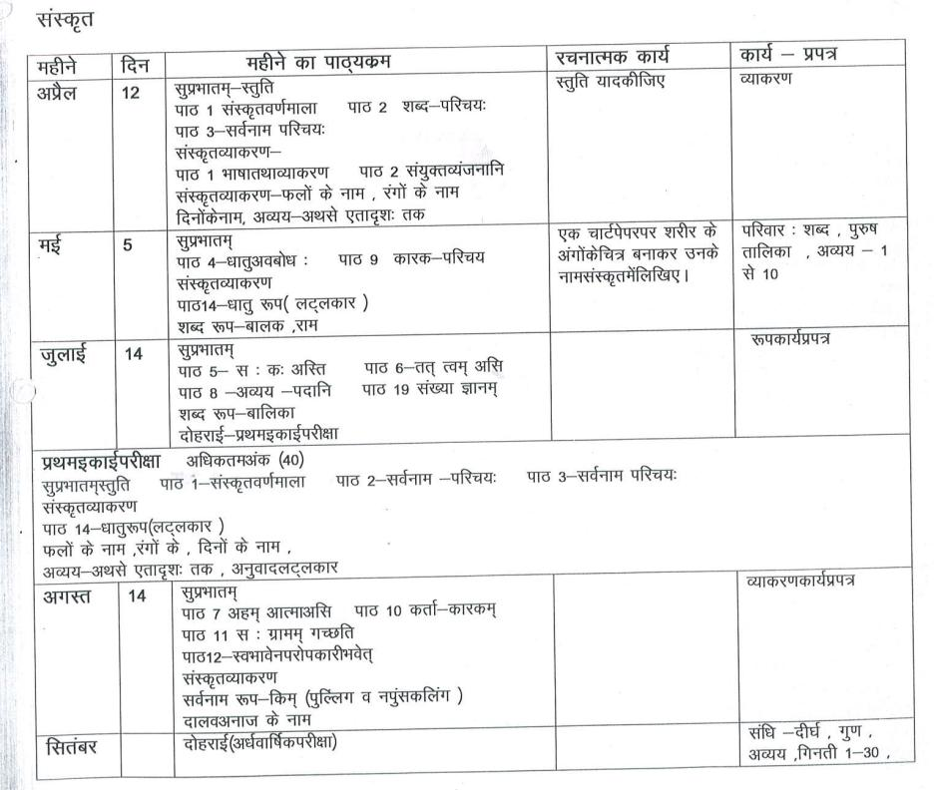

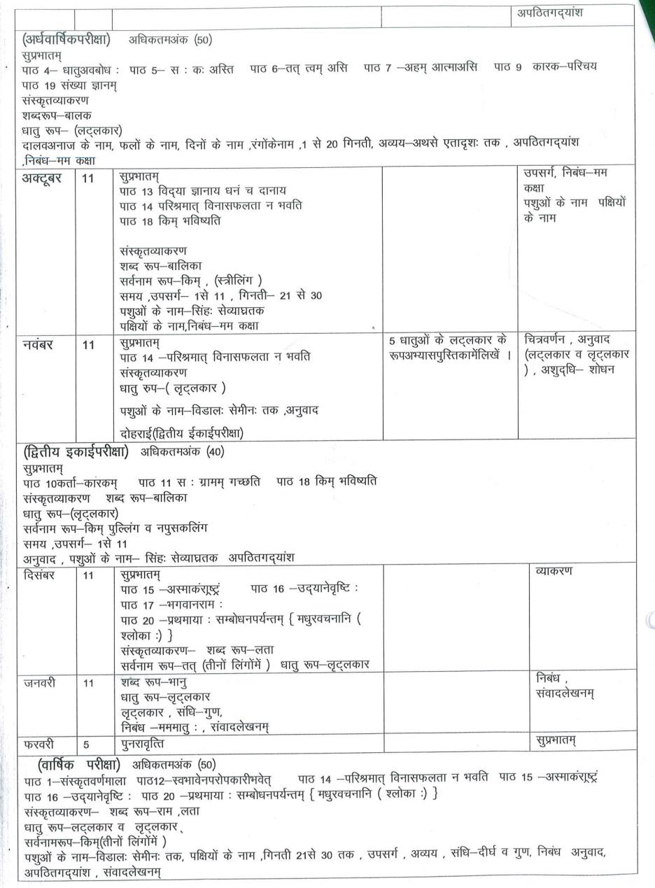
Comp.
Month | No. of Days | Content |  | Practical
April | 18 | Ch – 1 : The Computer System |  | Excel : Font Formatting, Alignment & Orientation of Data, Number formatting, cell style  Practical of MS Excel
May | 8 | Ch – 2 : Formatting Data In  Excel 2016
July | 10 | Ch – 3: Advance Feature of  Excel 2016  Revision
WRITTEN EVALUATION SYLLABUS: P.A-II M.M. 30
Ch- 1, 2
Aug |  | Ch – 4 : Paint 3D | Paint:2D/3D shapes, applying stickers
Sep |  | Revision
WRITTEN EVALUATION SYLLABUS: Half Yearly M.M 80
Ch – 2, 3, 4
Oct |  | Ch – 5 : Basic of MS Small  Basic | Small Basic : Basic of small Basic, Elements. Conditional statements in small basic
Nov |  | Ch – 6 : Connect & Communicate
WRITTEN EVALUATION SYLLABUS: P.A – II M.M 30
Ch – 5,6
Dec |  | Ch – 7 : Introduction to  Adobe Animate CC | Animate CC : Use of Lasso and selection Tools etc. Rectangular Primitive tool, Drawing oval shapes. Creating Animation using Shaping , Motion Tweening
Jan |  | Ch – 8 : Drawing tools in  Animate CC
Feb |  | Ch – 9 : Creating Animations in Animated CC
WRITTEN EVALUATION SYLLABUS: Yearly Exam M.M 80
Ch – 7, 8, 9

G.K.
Months | Days | Content
April |  | Page no. 3 to Page no. 14
May |  | Page no. 15 to Page no. 18 and  Page no. 70
July |  | Page no. 19 to Page no. 21 and Page no. 68  Revision
Written Evaluation Syllabus: PA-1(July) M.M.-30
Page no. 63 to Page no. 18 and Page no. 70
August |  | Page no. 22 to Page no. 36  Current Affairs
September |  | Revision
Written Evaluation Syllabus: Half Yearly Exam(September) M.M.:-40
Page no. 15 to Page no. 36 and Page No. 68
Current Affairs
October |  | Page no. 37 to Page no.48 and Page no. 71
November |  | Page no. 49 to Page no. 51  Revision
Written Evaluation Syllabus: PA-II(November) M.M.-30
Page no. 37 to Page no. 48 and Page no. 71
December |  | Page no. 52 to Page no. 66
January |  | Page no. 67, Page no. 69 and Page no. 72  Current Affairs , Revision
February |  | Revision
Written Evaluation Syllabus: Yearly Exam(February) M.M.-40
Page no. 49 to Page no. 67 Page no 69, 72 Current Affairs

Drawing & Art/Craft
Month | Number of Days |  | Pages of Art Book | Activity
April | 20 |  | Elements of Art  Nature study | Collage work
May | 8 |  | Bird Study
July | 24 |  | Landscape | Stencil art
August | 25 |  | composition  object study
September | 4 |  | Revision
Half yearly--- nature study, bird study, landscape, composition
October | 19 | Poster Design |  | Rangoli Design
November | 14 | Historical monuments |  | Designer crown
December | 18 | warli Art |  | Quilling art
January | 10 | sketching
February |  | Revision
Yearly--- Poster design, historical monument, warli art
French

LES MOIS | LE GRAMMAIRE | LES VOCABULAIRES | LES DIVERS
AVRIL | 1.Pronom.  2. Les articles. | 1. Les salutations.  2. L’alphabet.  3. Les nombres/ chiffres. | 1. Representez-vous
MAI | 1.Conjugation d’ etre and avoir. | 1.Les jours de la semaine  2. Les moins de l’annee | 1. les formation du phrases.
JUILLET | 1.Nationalites. | 1. Les fruits.  2. Les legumes. | 1.Comprehension d’ecrit.
PA 1 (30) | 1.Conjugation d’ etre and avoir.  2. Pronom. | 1. Les jours de la semaine.  2. Les legumes  3. Les salutations. | 1.Comprehension d’ecrit  2. Les nombres/ chiffres
AOUT | 1.L’Adjectifs.  2. 1. conjugation de verbs “ER”. | 1.La famiile d’ecric.  2. Les couleurs | 1.Comprehension d’ecrit
SEPTEMBRE | 1. conjugation de verbs “ER”. | 1. Les nombres ordinaux.  2.Les corps du partie. | 1.Comprehension d’ecrit
HALF YEARLY  (40) | 1. Conjugation d’ etre and avoir.  2. conjugation de verbs “ER”.  3. Pronom  4.L’adjectifs | 1. La famiile d’ecric.  2. Les couleurs.  3. Les fruits. | Les nombres ordinaux.
OCTOBRE | 1. Conjugation de verbs  “IR” AND “RE”. | 1.Phrases avec le verb faire .  2. Les corps du partie. | Completez les pharses avec l’aide verbs
NOVEMBRE | 1.Le temps | 1. Les Repas.  2. Les vetements. | 1.Comprehension d’ecrit.
PA 2(30) | 1. Conjugation de verbs  “IR” AND “RE”.  2. Pronom.  3.L’Adjectifs | 1.Phrases avec le verb faire .  2. Les Repas.  3. Les vetements. | 1.Completez les pharses avec l’aide verbs
DECEMBRE | - Pronom  - Les articles  - Verbs –ER,IR ,RE | -------------------------------- | 1.Le temps .
JANVIER | - AVOIR ET ETRE excercises.  - Exercise sur le sujet verbs , articles. | ------------------------------- | 1.Comprehension d’ecrit .  2. Completez les pharses avec l’aide verbs.
YEARLY | 1. Conjugation d’ etre and avoir.  2. Conjugation de verbs “ER”.  3. Pronom  4.L’adjectifs  5. Conjugation de verbs  “IR” AND “RE”. | 1.La famiile d’ecric.  2.Phrases avec le verb faire.  3. Les Repas.  4. Les vetements | 1.Comprehension d’ecrit .  2. Completez les pharses avec l’aide verbs.

